

Dr. Theodore, Edwards inc.

2017-09-30

Dr. Edwards

9284 Randy Rapids Suite 029, Smithberg, UT 21861

Phone: 9000149940

Fax: 6032282146

**Re:** Pam, Lawrence

**PHN:** 7040958573

**Birthdate:** 15-Dec-1963

**Address:** 61313 Pham Summit Apt. 315, Lake Katie, TN 55983

**Patient number:** 3170431639

To Whom It May Concern:

This is a medical letter to state the above patient is pregnant with expected delivery date of 03-Feb-2025. Hoping this information is satisfactory for your requirements.

Thank you.

Sincerely,

Dr. Theodore, Edwards

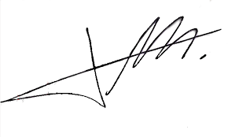

FRCS© NCMP

Clinical Assistant Professor, UBC

Department of Obstetrics and Gynecology SMH